Software Requirements Specification

Version 1.0

<<Annotated Version>>

Mayo 16,2021

Lilas mshref

Bayan almoshantaf

Aya albetar

Kafa alnajar

Al Birr Charity Association web site

<<Any comments inside double brackets such as these are not part of this SRS but are comments upon this SRS example to help the reader understand the point being made.

Refer to the SRS Template for details on the purpose and rules for each section of this document. >>

**Table of Contents**

List of Figures…………….

1. Introduction………………………………2

1.1Purpose………………………………2

1.2Scope of Project…………………………………………2

1.3. Glossary………………………………3

1.4. References……………………………………………………4

1.5. Overview of Document…………………..5

2.0. Overall Description…………………….6

2.1 System Environment………………………………..6

2.2 Functional Requirements Specification…………….6

2.2.1……………….6

Use case: send a message to refresh the information

2.2.2……………………….7

Use case: add advertising

2.2.3……………………………8

Use case: log in association

3.0. Requirements Specification……………………9

3.1 External Interface Requirements…………………………9

3.2 Functional Requirements………………….9

3.2.1………………………………….9

send a message to refresh the information

3.2.2…………………………………….10

The employee adds an advertisement

3.2.3………………………11

Sign in by person

3.3 Detailed Non-Functional Requirements

3.3.1 Logical Structure of the Data:…………………13

3.3.2 security…………………16

1. **Introduction:**
   1. ***Purpose***

The purpose of this document is to provide a detailed description of the work system at Al Ber Charity Society. It will explain the purpose and features of the system, the interfaces of the system, what the system will do, the limitations under which it must operate and how the system will interact with external stimuli. This document is intended for both stakeholders and system developers and will be proposed to the charity for approval.

* 1. ***Scope of Project***

This program system will be a system to automate the work of Al Ber Charitable Society for a local community. This system will be designed to maximize performance and work productivity by providing tools to help automate family registration to association and posting advertisements, which would otherwise have been done manually. By increasing the efficiency of the site's work and production, the system will meet the needs of the charity while maintaining its ease of understanding and use.

More specifically, this system is designed to allow the management of the charity to manage a group of families, people, and employees, and to communicate with them to help them and provide the necessary aid on a website. The program will facilitate communication between employees and people registered in the charity via e-mail or by the person’s number. At every stage of the advertisements progress and the input of information through the system to save time and effort. The system also contains a relational database containing a list of employees, family and people.

* 1. ***Glossary***

|  |  |
| --- | --- |
| All the information needed to register with the charity | Database |
| A cell within a form. | Field |
| A document that completely describes all of the functions of a proposed system and the constraints under which it must operate. For example, this document. | Software Requirements Specification |
| It is a message to inform the person whether he was approved by the charity or not | Status message |
| Any person with an interest in the project who is not a developer. | Stakeholder |
| Employees, people or families | User |

* 1. ***References***

IEEE. *IEEE Std 830-1998 IEEE Recommended Practice for Software Requirements Specifications.* IEEE Computer Society, 1998.

* 1. ***Overview of Document***

The next chapter, the Overall Description section, of this document gives an overview of the functionality of the product. It describes the informal requirements and is used to establish a context for the technical requirements specification in the next chapter.

The third chapter, Requirements Specification section, of this document is written primarily for the developers and describes in technical terms the details of the functionality of the product.

Both sections of the document describe the same software product in its entirety, but are intended for different audiences and thus use different language.

1. **Overall Description**

2.1 .***System Environment***

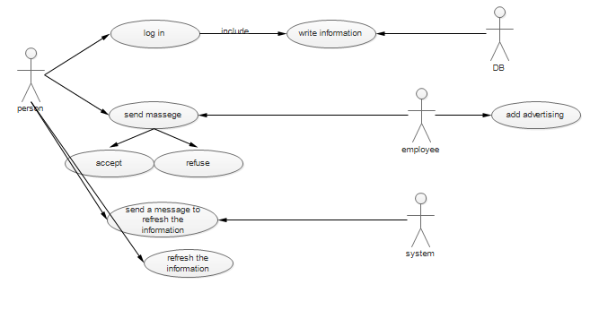

The Web site has three active actors and one cooperating system.

The person can log in association to benefit from their projects . The employee accesses to requests and process it.

The system should send a messages (automatically) to refresh person's information.

**2.2 *Functional Requirements Specification***

This section outlines the use cases for each of the active member separately .

The system has only one use case and the employee has two

use cases while the person is main actor in this system.

2.2.1 system Use Case

Use case: send a message to refresh the information

Diagram:

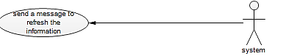

Brief Description:

The system can access to person's information and send a message to refresh them at specific time.

Initial Step-By-Step Description :

Before this use case can be initiated, the system has already accessed the database.

The system knows date whine person log in database.

The system subtracts these date and today.

If the period equal one year the system send message to person to refresh his information.

Xref: Section 3.2.1, Search Article.

2.2.2 employee use case

Use case: add advertising

Diagram:

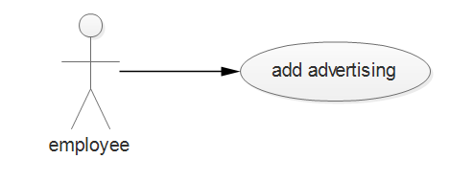 Description:

The employee can add advertising to the website to tell people about times to procurement their things(money, food , medicine ……etc)

Initial Step-By-Step Description:

Before this use case can be initiated, the employee has already accessed to database.

1. The employee log in database
2. The employee find people whose need the money or food or….
3. The employee make an advertising to tell them to come association for get their assistance .
4. People come to association without crowding

Xref: Section 3.2.2, Communicate

2.2.3 person Use Case

Person whose need aid like (poor family , student , patient ,…) and the aid is (money , food, clothes …..)

Use case: log in association

Diagram:

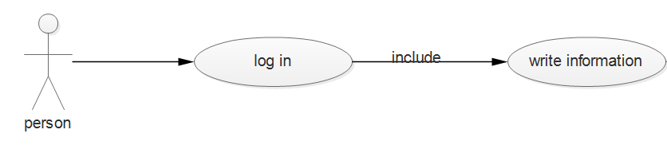Brief Description:

The person should write his information to log in association

Initial Step-By-Step Description:

Before this use case can be initiated, the person has already access to website.

The person write his information and full of the form

The employee resave the information and offer it to select committee

These committee are meeting every two week

if person is really need aid the committee are accept him but if the information are not enough they refuse him

the employee send a message to person to tell him if he accept or refuse

Xref: Section 3.2.3, Communicate

**2.4 *Non-Functional Requirements***

The site will be safe and confidential because it will deal with very important and privacy data

The site will be accurate, always available to users, and can be accessed at any time and place.

The responsible employee will work on the computer that contains the "mysql" database and this machine will work on the windows operating system

1. **Requirements Specification:**
   1. ***External Interface Requirements:***

the link to an external system is the link to the database mysql

The customer logs into the site The fields built into the database (the ID number, name ,Mother's name,Name of the Father,husband name,wife's name,The number of individuals,Sex,Family status,date of Birth,place of birth, Telephone number, Address,Charity approval , Relief type,Provision amount,Health card number,Exemption rate)

And when you press the Send button, information is stored(Date of request,Request status)

There are fields for charity services(the id , name services , type services,Activate the service)

* 1. ***Functional Requirements:***

The Logical Structure of the Data is contained in Section 2.2.1.

3.2.1. the site send a message to refresh the information

|  |  |
| --- | --- |
| use case name: | send a message to refresh the information |
| XRef: | Section 2.2.1,send a message to refresh the information |
| Trigger: | the system send message to the person to refresh his information |
| Precondition: | That the person has a previous registration from the charity to update his data |
| Basic Path: | 1-the system knows data whine person log in database.  2-the system subtracts these data and today  3-if the period equal one year the system send message to person to refresh his information |
| Alternative Paths: | none |
| Postcondition: | After the customer receives the message, he updates his information |
| Exception Paths: | The message can not be communicated to the person |
| others: | none. |

3.2.2 The employee adds an advertisement

|  |  |
| --- | --- |
| use case name: | adds advertisement |
| XRef: | Section 2.2.2 |
| Trigger: | The employee publishes an advertisement on the site |
| Precondition: | none |
| Basic Path: | 1. the employee log in database 2. The employee find people whose need the money or food or…. 3. the employee make an advertising to tell them to come association for get their assistance . 4. People come to association without crowding |
| Alternative Paths: | Sending an SMS to the person in case he did not see the advertisement on the site |
| Postcondition: | Pre-registered with the charity |
| Exception Paths: | none |
| others: | none |
|  |  |

3.2.3 : Sign in by person

|  |  |
| --- | --- |
| use case name: | : Sign in by person |
| XRef: | section 2.2.3 |
| Trigger: | Customer reviews the web page and input information |
| Precondition: | Internet is available |
| Basic Path: | 1. The person browses the web page, logs it in, and enters all the information 2. The employee resave the information and offer it to select committee 3. These committee are meeting every two week 4. if person is really need aid the committee are accept him but if the information are not enough they refuse him 5. the employee send a message to person to tell him if he accept or refuse |
| Alternative Paths: | If it is not approved by the committee, the person will refuse  A rejection letter is sent to the person  Try again when another advertisement is read by the charity |
| Postcondition: | Register the request in the database |
| Exception Paths: | A person may close the browser or cancel the process at any time |
| others: | none |

***3.3: Detailed Non-Functional Requirements***

3.3.1 Logical Structure of the Data:

The logical structure of the data to be stored in the internal Article Manager database is given below.  
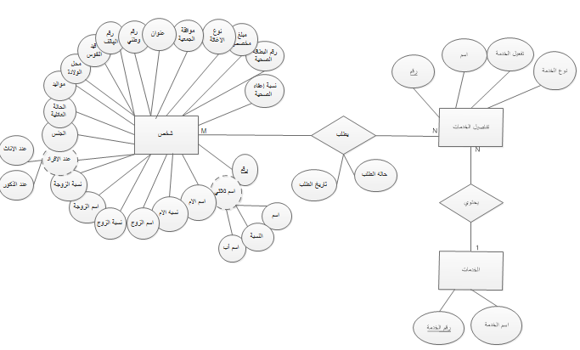

The data descriptions of each of these data entities is as follows:

The Person intety

|  |  |  |  |
| --- | --- | --- | --- |
| **Data Item** | **Type** | **Description** | **Comment** |
| Id | number | The person's number in the charity |  |
| Full name | object | First and last name and father's name | May be several |
| Father name | text |  |  |
| Mather name | text |  |  |
| husband name | text |  | Writes if it exists |
| wife's name | text |  | Writes if it exists |
| wife's last name | text |  |  |
| husband last name | text |  |  |
| The number of individuals | number | Number of Children |  |
| Sex | text | male or female |  |
| Family status | text | Standard of living |  |
| date of Birth | date |  |  |
| place of birth | text |  |  |
| Place of registration | text | Registration of birth information in the country |  |
| Telephone number | number | Person number |  |
| the ID number | number |  |  |
| Address | text | The person's current address |  |
| Charity approval | text | Was the person accepted into the charity? |  |
| Relief type | text | Food, clothing, health assistance, or ......... |  |
| Provision amount | money | A sum of money |  |
| Health card number | number | The card is from the charity |  |
| Exemption rate | double | Cost exemption percentage according to the information |  |
|  |  |  |  |

Service details entiety

|  |  |  |  |
| --- | --- | --- | --- |
| **Data Item** | **Type** | **Description** | **Comment** |
| Id | number |  |  |
| name | text |  |  |
| Type the service | text |  |  |
| Activate the service | bool |  |  |

The Services entiety

|  |  |  |  |
| --- | --- | --- | --- |
| **Data Item** | **Type** | **Description** | **Comment** |
| Id services |  |  |  |
| Name services |  |  |  |

3.3.2 Security

The server that the database resides on will have its own security to prevent unauthorized recording from occurring

The PC the manager is on will have its own security. A person will only have physical access to the device and the software on it. There is no special protection built into this system other than providing a person with it by typing information into the fields to store it in the database and then waiting for his acceptance.